Performance and Scaling
Ryan Coon
SDD-620
Dr. Benjamin Perez
September 9, 2026

Part 1
As a company grows and the volume of data increases, SQL queries that once performed efficiently may become slower due to the larger datasets and higher user demand. To optimize queries and improve performance, it is crucial to limit the data retrieved to only what is necessary. One effective way to view a subset of a table is by using the WHERE clause, which filters rows based on specific conditions, such as date ranges, customer regions, or status flags. Additionally, the LIMIT keyword (or TOP in some SQL dialects) restricts the number of rows returned, which is useful for previewing data or implementing pagination. These keywords help reduce the amount of data processed and transferred, improving query speed and resource usage.
Minimizing the retrieval of unnecessary data also involves avoiding the use of SELECT *, which fetches all columns from a table. Instead, explicitly specifying only the required columns reduces the data volume and speeds up query execution. For example, selecting only customer_id, name, and email instead of all columns in a customer table can significantly reduce overhead. Furthermore, reviewing the query to ensure that only relevant tables are included is essential. Sometimes queries join tables that are not needed for the final result or duplicate data, which unnecessarily increases complexity and processing time. Removing such redundant tables or optimizing join conditions can enhance performance.
To limit both columns and rows, combining SELECT column1, column2 with WHERE and LIMIT clauses is effective. This approach ensures that queries retrieve only the necessary subset of data, reducing load on the database engine. Additionally, indexing columns used in WHERE clauses can further speed up data retrieval by allowing the database to quickly locate relevant rows without scanning the entire table.
In summary, optimizing SQL queries for a growing dataset involve filtering rows with WHERE, limiting rows with LIMIT, selecting only necessary columns, and eliminating unnecessary table references. These practices reduce query complexity, improve response times, and help maintain database performance as the company scales.
Part 2
Database sharding is a method of partitioning a large database into smaller, more manageable pieces called shards. Each shard holds a subset of the overall data, distributed across multiple servers or nodes. This approach is particularly beneficial for large-scale applications, such as e-commerce platforms like Amazon, which manage millions of products and serve millions of customers worldwide. By dividing the database into shards, the system can distribute the workload, improve performance, and enhance scalability.
One of the primary benefits of database sharding is scalability. As the volume of data and user requests grows, a single database server may become a bottleneck, leading to slower response times and potential downtime. Sharding allows the database to scale horizontally by adding more servers, each responsible for a portion of the data. This means that Amazon can handle increasing product listings, customer transactions, and search queries without degrading performance. Horizontal scaling through sharding is more cost-effective and flexible compared to vertical scaling, which involves upgrading a single server’s hardware.
Another significant advantage is improved performance. Since each shard contains only a subset of the data, queries can be directed to the relevant shard rather than scanning the entire database. For example, Amazon could shard its product database by categories, geographic regions, or customer segments, enabling faster search and retrieval times. This localized data access reduces latency and improves the user’s experience, which is critical for maintaining customer satisfaction and competitive advantage.
Sharding also enhances availability and fault tolerance. If one shard or server experiences failure, the other shards can continue to operate independently, minimizing downtime and data loss. This distributed architecture supports high availability, which is essential for e-commerce platforms that operate 24/7 globally.
However, sharding introduces complexity in managing data consistency and executing cross-shard transactions, requiring sophisticated application logic or middleware to coordinate operations across shards. Despite these challenges, the benefits of sharding in handling massive datasets and high traffic volumes make it indispensable for companies like Amazon.
Database sharding enables large e-commerce companies to efficiently manage vast product inventories and high user demand by improving scalability, performance, and availability. It allows platforms like Amazon to grow seamlessly while maintaining fast, reliable access to data.

Part 3
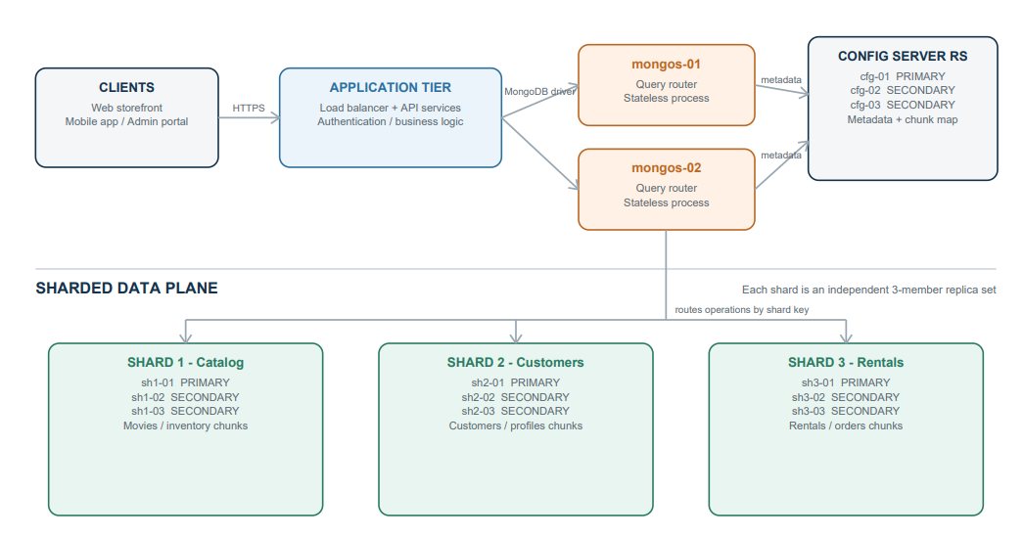

References
Aerospike. (2025). Understanding database sharding for scalable systems. Retrieved from https://aerospike.com/blog/database-sharding-scalable-systems/
Coronel, C., & Morris, S. (2023). Database systems: Design, implementation, and management (14th ed.). Cengage Learning.
Yugabyte. (2025). What Is Database Scalability? Strategies for Scaling Your Database. Retrieved from https://www.yugabyte.com/key-concepts/what-is-database-scalability/

